KSE Webinar: Truck loading concepts for finished feed

Q&A Summary

Question 1: How effective is the dust collecting system on the BUVT when loading or unloading? Can you actually keep the loadout area clear of dust?
During the loading process, the weigher is docked onto the silo or slide so no dust can disappear there.
The filter is sucking in more air than the replaced air during the filling the weigher. This will be compensated by a ‘false’ air valve*. When driving, the upper dust seal is down and the false air valve is closed. The filter still runs so the weigher still has a small vacuum. This means there is always a draft that is sucked into the weigher, meaning there also cannot be a lot of dust. The moment you empty the weigher, the lower dust seal docks onto a contra cell or a loading bellow is lowered onto the truck, with the filter still working.
When the loading bellow is connected to the filter, it can also suck away the replaced air of the truck. Naturally there will be some very fine dust during the loading in the bulk street. However, mostly we see pellets or meal on the floor having a different cause than the filter not working correctly in combination with the weigher.
*Note: the false air valve is not a default option on the BUV, but looked at case by case whether this is suitable for your plant.

Question 2: Is using grid slides also recommended when loading mash products, such as flakes and pellets?
When you are loading flakes and pellets, we would strongly recommend grid slides, also in combination with a vibrating bottom, but with a flat slide this will work too. When it is just flakes and no vibrating bottom, the use of a big grid slide is almost mandatory to have no force on the flakes, avoiding any damage as much as possible.
The surface size of the funnel outlet also matters because the pressure is at the end of the funnel. The smaller it gets, the more pressure you have there. When you have a big discharge surface, you also have a big surface on your funnel and less pressure on your flakes. The grid slide takes care of that.

Question 3: A question related to capacity. Certain concepts have come by where it is either direct loading or contra loading or the concept you showed with multiple layers of weighers on top of each other. Is the main reason to choose weighers on top of each other capacity? Or are there other reasons to go to such solution as well?
There are two reasons; one is of course the capacity because you can load the weigher and unload it very fast in the shuttle. The weigher is then already collecting new material and the shuttle can empty, so there you gain time.
However, due to the range it can also be necessary that you need two layers. In the picture below, you can see that there are 4 bulk streets, and all streets must be filled from each silo. When you see the weighers, they can only reach the contra cells in their area, so therefore we have installed these shuttles, to bring the product from the weighers to each contra cell there is.
So there is a question of flexibility and a question of capacity.
It is also possible that we have two layers above each other where you have direct loading, possibly going up to 80 tons per hour when loading a truck.
This solution could be preferred when loading of the truck is more a matter of just in time and most orders are standard feeds, in stock.

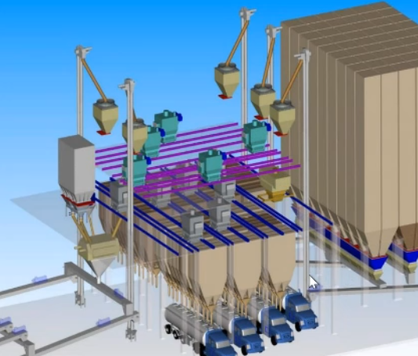

Question 4: I have seen grids on the contrasets’ inlets. Have you observed any damage on the pellets when it unloads from the weigher to the contraset and passing through the grids?
These grids are not so much damaging the pellets but can rather work as a brake, due to too small openings. Best is to round or sharpen the lamellae a little to make the top smaller.
The lamellae should ideally be 80 mm from each other, not a roster because then it will work as a brake and the unloading process will take longer.

Question 5: When bulk loading with different types of trucks, how do you reach the highest capacity? Is using contra cells a good option?
Different trucks can mean that the difference between the holes of the compartments differs, maybe even up to 1.5 meters.
The longer the 2 telescoping pipes (see picture below) are, the more flexibility you have for going from one hole to the other hole. The upper pipe of course must be hinged. Therefore, you can move it to the front or the back of the truck.
With less height of the trucks (difference in height of the trucks), you will need a longer pipe to reach the opening of the smaller ones.

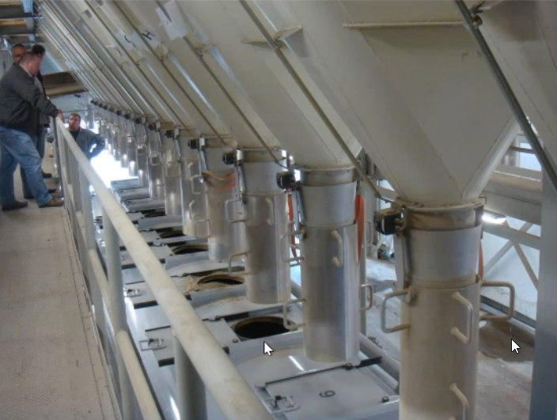

Question 6: If you put a static mixer inside of a bulk weigher does that require more height or any other adaptions?
The only thing you lose is the volume of the steel that you put in, but normally you keep the same amount of content of the weigher.
No extra height restrictions are needed, just adding the cross design (see below picture). The static mixing gives you a sufficient mix but it’s not the same as the mixer mix that we have talked about in the presentation. It really depends on the level of mixing that you need for your finished feed.

Of course, each compartment needs a kind of opening to get inside. So when you prefer to mix in an already existing weigher, this has to be built in.
Also the (back-to-back opening as we call it) double slide at the bottom is needed because you need to open each quadrant separately.

